creative industry resources

www.rga.com This website is an excellent overview of what they do in a Digital Design business.
See how they divide their company up. There are videos with people talking which will provide some job titles and a sense of what it is they do by the content of the videos.
http://bestawards.co.nz/ Explore all categories and look for student awards to see who is studying where.
www.joynlondon.com An example of a full service digital design consultancy based in London.

Social Marketing is very specific. www.wearesocial.com It's worth noting that ALL advertising agencies have or will be embracing social media and this division reflects the time we're living in.
This is a very interesting article. http://wearesocial.net/blog/2010/12/future-advertising-advertising/

Harvard Business Review www.hbr.org
Branding in the digital age
http://hbr.org/2010/12/branding-in-the-digital-age/ar/1
Reputation Warfare
http://hbr.org/2010/12/reputation-warfare/ar/1
The One Thing You must get Right When Building a Brand
http://hbr.org/2010/12/the-one-thing-you-must-get-right-when-building-a-brand/ar/1

E-marketing and Internet marketing definition: “Achieving marketing objectives through applying digital technologies.”
These digital technologies include Internet media such as web sites and e-mail as well as other digital media such as wireless or mobile and media for delivering digital Television such as cable and satellite. In practice, Internet marketing will include the use of a company web site in conjunction with online promotional techniques such as search engine marketing, interactive advertising, e-mail marketing and partnership arrangements (affiliate marketing) with other web sites. I identify 6 main types of digital media communications channels: 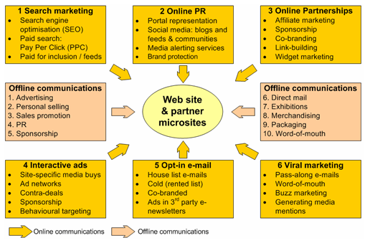
These can be facilitated through the desktop or mobile web. However, for Internet marketing to be successful there is still a necessity for integration of these techniques with traditional media such as print, TV and direct mail. This is multi-channel E-marketing.

E-marketing definition:
E-marketing can be considered to be equivalent to Internet marketing. Most in the industry would look at it this way. However, E-marketing is sometimes considered to have a broader scope since it refers to digital media such as web, e-mail and wireless media, but also includes management of digital customer data and electronic customer relationship management systems (E-CRM systems).
Digital marketing definition:
Digital marketing is yet another term similar to E-marketing. I reference it here, because it is a term increasingly used by specialist e-marketing agencies and the new media trade publications. The Institute of Direct Marketing has also adopted the term to refer to its specialist professional qualifications. http://www.davechaffey.com/Internet-Marketing
"Digital marketing involves:
Applying these technologies which form online channels to market: Web, e-mail, databases, plus mobile/wireless & digital TV).

To achieve these objectives:
Support marketing activities aimed at achieving profitable acquisition and retention of customers… within a multi-channel buying process and customer lifecycle

Through using these marketing tactics:
Recognising the strategic importance of digital technologies and developing a planned approach to reach and migrate customers to online services through e-communications and traditional communications. Retention is achieved through improving our customer knowledge (of their profiles, behaviour, value and loyalty drivers), then delivering integrated,
targeted communications and online services that match their individual needs.

The first part of the description illustrates the range of access platforms and communications tools that form the online channels which e-marketers use to build and develop relationships with customers. The access platforms or hardware include PCs, PDAs, mobile phones and interactive digital TV and these deliver content and enable interaction through different online communication tools such as organisation web sites, portals, search engines, blogs (See Chapter 8), e-mail, instant messaging and text messaging. Some also include traditional voice telephone as part of digital marketing.

The second part of the description shows that it should not be the technology that drives digital marketing, but the business returns from gaining new customers and maintaining relationships with existing customers. It also emphasises how digital marketing does not occur in isolation, but is most effective when it is integrated with other communications channels such as phone, direct mail or face-to-face. As we have said, the role of the Internet in supporting multi-channel marketing is another recurring theme in this book and chapters 5 and 6 in particular explain its role in supporting different customer communications channels and distribution channels. Online channels should also be used to support the whole buying process from pre-sale to sale to post-sale and further development of customer relationships.

Multi-channel marketing
Customer communications and product distribution are supported by a combination of digital and traditional channels at different points in the buying cycle.

The final part of the description summarises approaches to customer-centric e-marketing. It shows how success online requires a planned approach to migrate existing customers to online channels and acquire new customers by selecting the appropriate mix of e-communications and traditional communications. Retention of online customers needs to be based on developing customer insight by researching their characteristics, behaviour, what they value, what keeps them loyal and then delivering tailored, relevant web and e-mail communications.

Customer insight definition
Knowledge about customers needs, characteristics, preferences and behaviours based on analysis of qualitative and quantitative data. Specific insights can be used to inform marketing tactics directed at groups of customers with shared characteristics

